**Cramer’s Rule for a 3×3 System**

**(with Three Variables)**

Formula to Find the Determinant of a 3⨉3 Matrix

* Given a 3⨉3 matrix

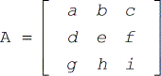

* Its determinant can be calculated using the following formula.

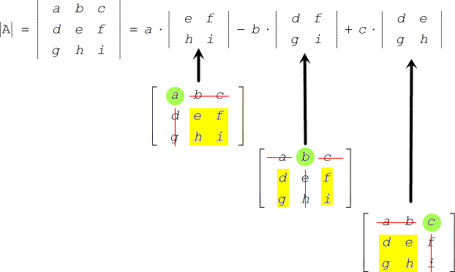

Example:

Find the determinant of matrix A

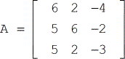

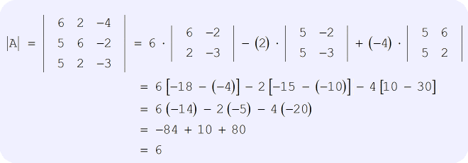

Now, it’s time to go over the procedure on how to use Cramer’s Rule in a linear system involving three variables.

Cramer’s Rules for Systems of Linear Equations with Three Variables

* Given a linear system

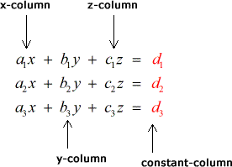

* Labeling each of the four matrices

**Coefficient matrix:**

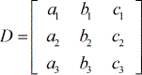

**X – matrix:**

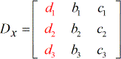

**Y – matrix:**

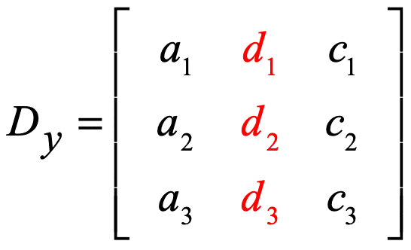

**Z – matrix:**

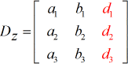

* To solve for x:

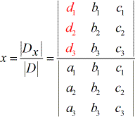

* To solve for y:

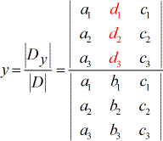

* To solve for z:

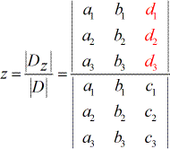

**Things to observe from the setup above:**

* 1. The coefficients of variables x, y, and z make use of subscripted a, b, and c, respectively. While the constant terms use subscripted d.
  2. The denominators to find the values of x, y, and z are all the same which is the determinant of the coefficient matrix (coefficients coming from the columns of x, y, and z).
  3. To solve for x, the coefficients of the x−column is replaced by the constant column (in red).
  4. To solve for y, the coefficients of the y−column is replaced by the constant column (in red).
  5. In the same manner, to solve for z, the coefficients of the z−column is replaced by the constant column (in red).

**Example 1**: Solve the system with three variables by Cramer’s Rule.

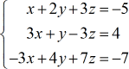

Construct four matrices that will be used to solve for the values of *x*,  *y*, and *z*.

* **Coefficient matrix**

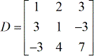

* **X – matrix**

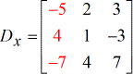

* **Y – matrix**

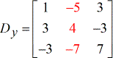

* **Z – matrix**

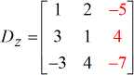

The values of the determinants are listed below.

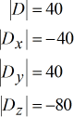

Solved values for *x*,  *y*, and *z*.

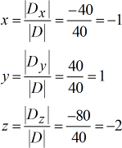

The final answer written in point notation is

{x, y, z} = (−1,1,−2).

**Example 2**: Solve the system with three variables by Cramer’s Rule.

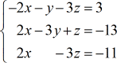

**Solution:**

* **Coefficient matrix**

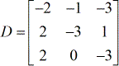

* **X – matrix**

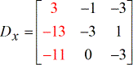

* **Y – matrix**

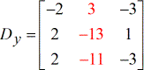

* **Z – matrix**

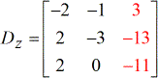

Determinants of each matrix:

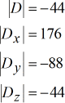

The values for x, y and z are calculated as follows:

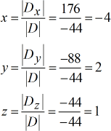

Our final answer is (*x*, *y*, *z*) = (−4, 2, 1).

**Example 3**: Solve the system with three variables by Cramer’s Rule.

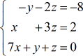

* **Coefficient matrix**

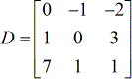

* **X – matrix**

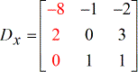

* **Y – matrix**

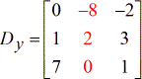

* **Z – matrix**

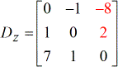

Determinants of each matrix:

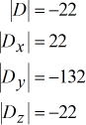

Values for x, y, and z are as follows:

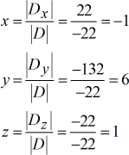

The final answer is (*x*, *y*, *z*) = (−1, 6, 1).

**Example 4**: Solve the system with three variables by Cramer’s Rule

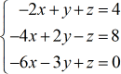

Write down the four special matrices.

* **Coefficient matrix**

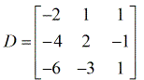

* **X – matrix**

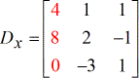

* **Y – matrix**

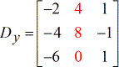

* **Z – matrix**

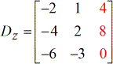

Determinants of each matrix:

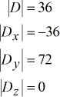

Values for *x*,  *y*, and *z* are:

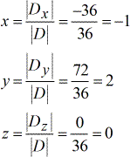

The final answer is (*x*, *y*, *z*) = (−1, 2, 0).

**Example 5**: Solve the system with three variables by Cramer’s Rule

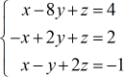

Construct the four special matrices.

* **Coefficient matrix**

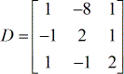

* **X – matrix**

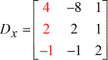

* **Y – matrix**

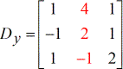

* **Z – matrix**

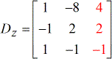

**Determinants of each matrix**

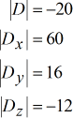

Values for *x*,  *y*, and *z* are:

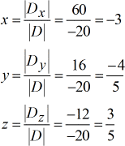

The final answer in point form is  (*x*, *y*, *z*) = (−3, −54​, 53​).